DOCKER EXERCISE 01

**1. Create a docker container using Ubuntu image & check Ubuntu Image is**

**fetched/created locally.**

**2. Check the Ubuntu docker container to see it is only in the created state.**

**3. Run the Ubuntu docker container and check the State of the container & it must be**

**running**

**Answer:**

● We have the ubuntu image downloaded locally in our laptop, so we directly run the

container.

# docker container create --name MY-Ubuntu ubuntu

#docker container ls -a

This command will create a container with our ubuntu image. And we can chech the

status by the command ls -a

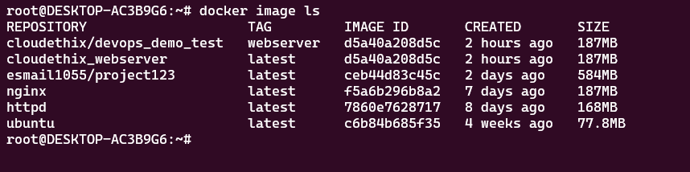

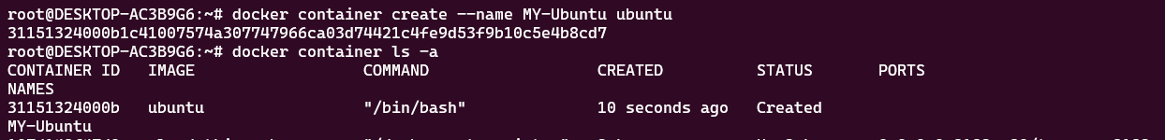

# docker run -itd --name MY-Ubuntu ubuntu

This command will run a docker container using ubuntu image, and it will have a

interactive terminal which will be detached from our wsl terminal.

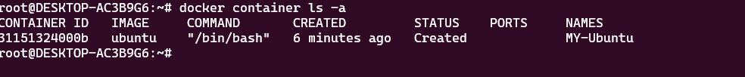

● Now, we will try to go inside of the container and exit without stopping the container

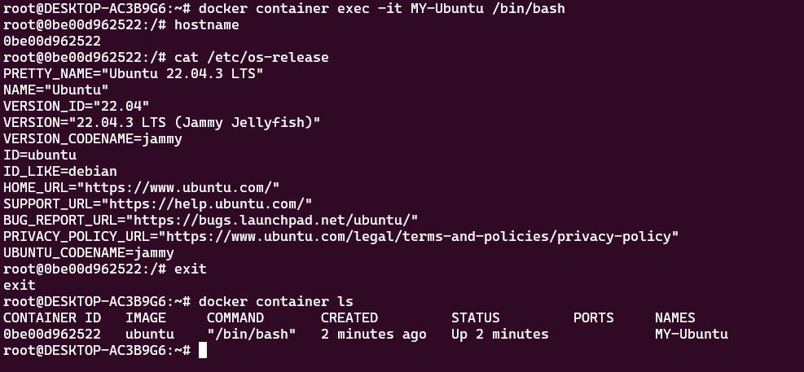

This is the completion of Answer no. 1, 2,3

**4. Run an HTTP container and check the state of the**

**container. Then delete the container and image from the**

**local system.**

**Answer:**

● For httpd container we use the command

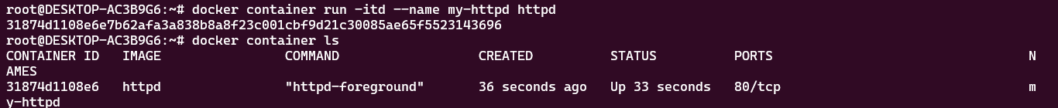

● Now, we have the httpd image in our local system, we will now delete the container

and image from the local system.

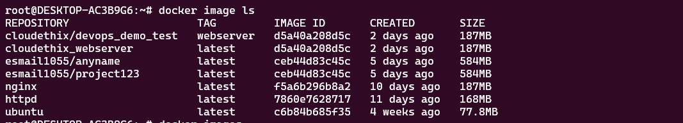

● First we need to stop and remove all the containers associated with the httpd image

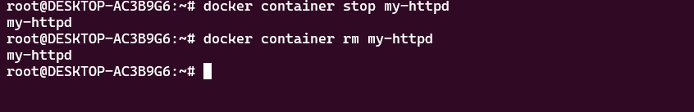

● We have now deleted the httpd image from our local system and stopped the

containers too.

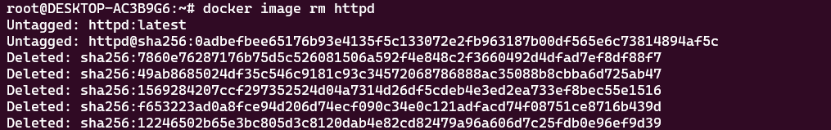

This is the completion of Answer no. 4

**5. Run a command to filter the containers with short**

**container IDs for all the containers.**

● For getting short IDs of the conatiners, we use the below command.

docker container ls -q

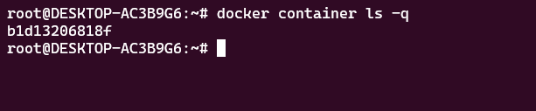

This is the completion of Answer no. 5

**6. Clone the lancachenet/ubuntu-nginx Git repo locally and**

**build the docker image from the Dockerfile. Please add**

**meaningful tags while building the docker image.**

**7. Once the Image is built , run the Docker container from the**

**image. And access the webpage using curl command to**

**check the webpage.**

**Answer:**

● First we clone the git repo in our local system

Repo-

<https://github.com/lancachenet/ubuntu-nginx>

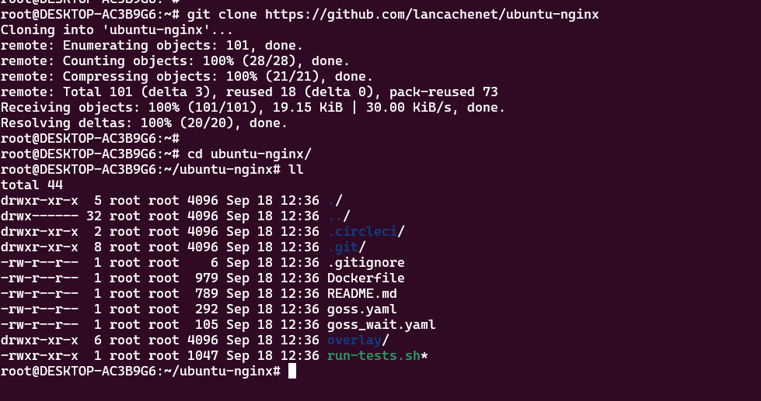

● Now we build the image using the Dockerfile

# docker image build -t esmail1055/cloudethix-ubuntu-ngnix .

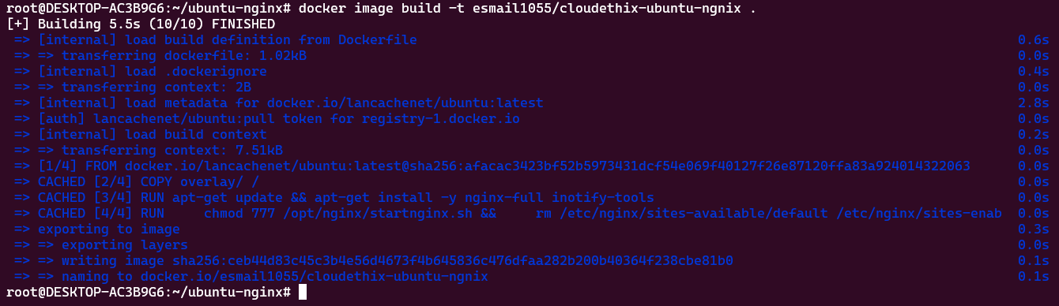

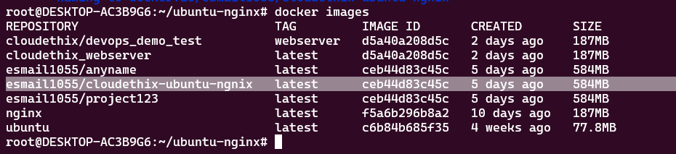

● Now we run the container using the image that was built

# docker container run -itd --name MY-nignix-ubuntu -p 80:80

esmail1055/cloudethix-ubuntu-ngnix

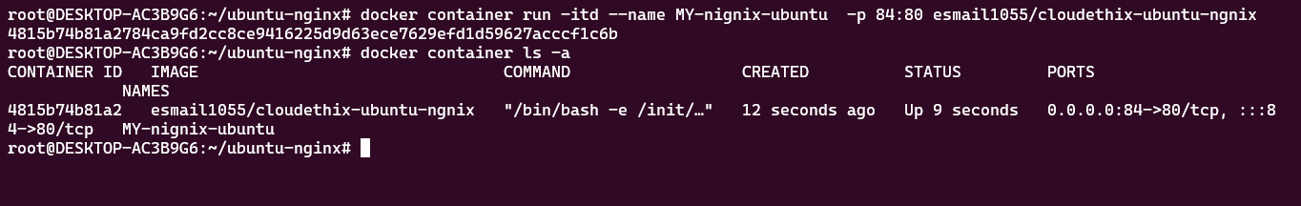

● We were able to access the webpage

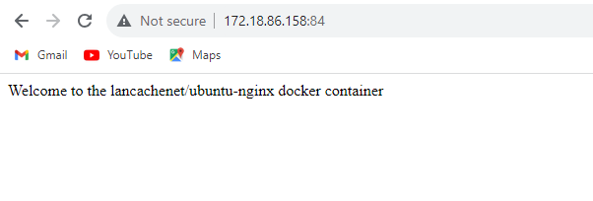

This is the completion of Answer no.6, 7

**8. Create a DockerHub account & create one repository in**

**your account with name cloudethix_devops_yourname.**

**Then tag the locally created docker image with using**

**your_repo_name/application_name:version_number**

**Answer:**

● We have made an account on docker hub and we were able to login using our

terminal

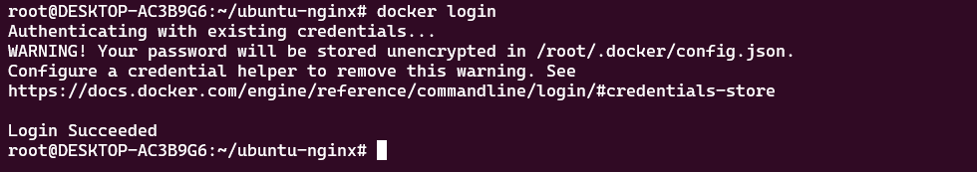

● As we have already tagged the image while building, we can directly push the image

to docker hub and we are able to see the image pushed at the dockerhub too.

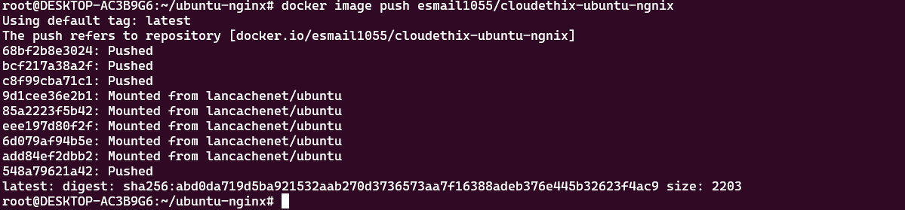

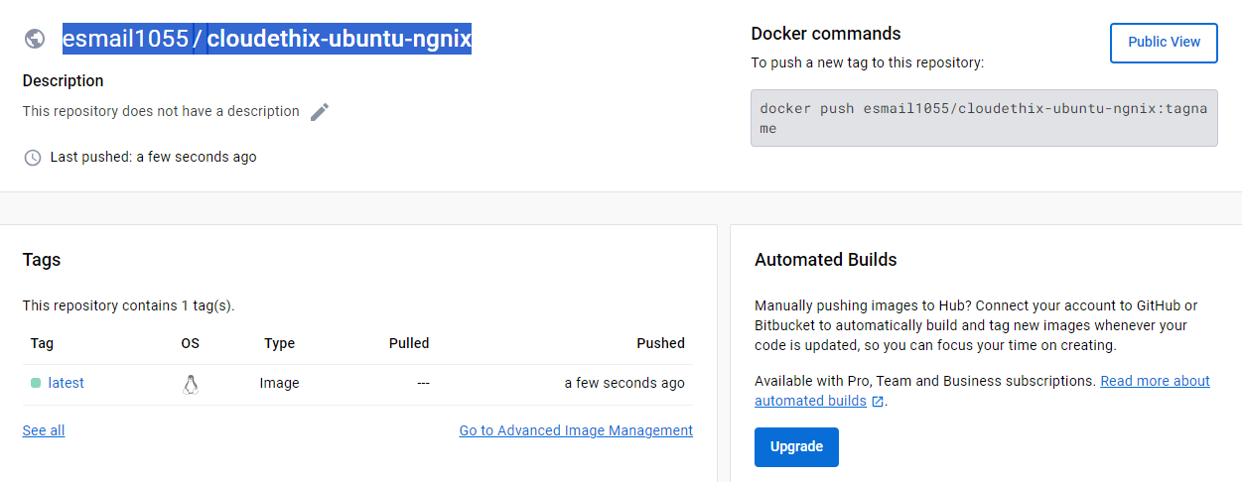

This is the completion of Answer no. 8

**9. Run the ubuntu container & prove that the escape**

**sequence is working. Also once you detached the container**

**with an escape sequence , re-attach the same and check**

**the IP address of the container.**

● We have run the container and we are able to use the /bin/bash shell

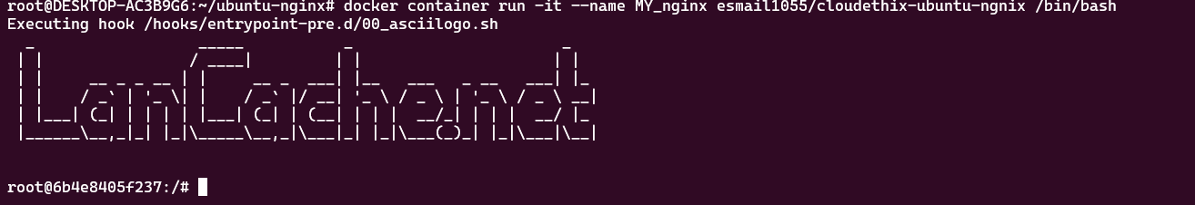

● We have exited the conatiner without stpooing it using ctrl+p+q



● We are able to reattach the container and check the ip

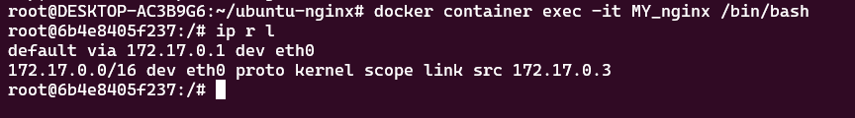

This is the completion of Answer no. 9

**10. Run a docker command to check the hostname &**

**/etc/hosts file of the httpd container.**

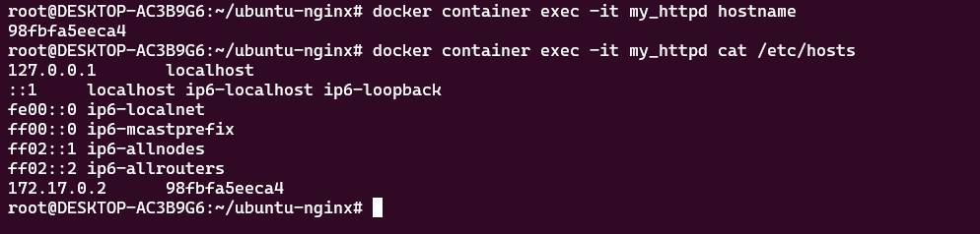

This is the completion of Answer no. 10

**11. Run a docker command to inspect a container created**

**using lancachenet/ubuntu-nginx repo. Also check the stats**

**and resources utilization using TOP of same container.**

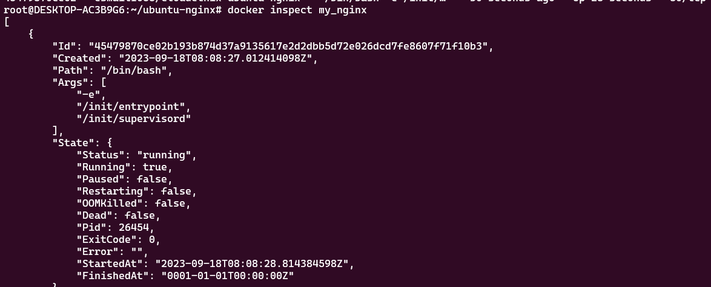

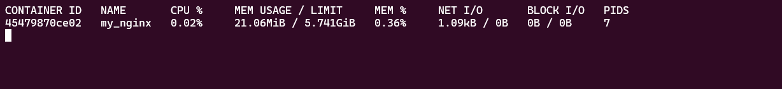

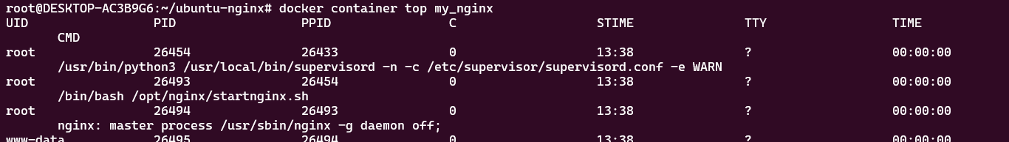

This is the completion of Answer no. 11

**12.Create a new Nginx container & check the logs of the both**

**nginx containers.**

**Answer:**

● Below are the outputs of the required commands

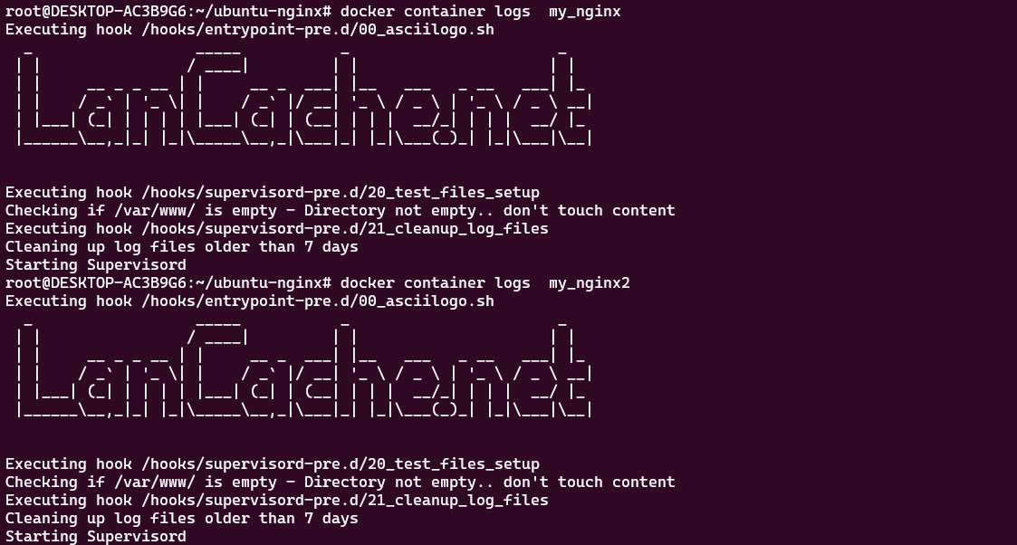

This is the completion of Answer no. 12

**13.Check the System events and filter out the event by date &**

**last 30 mins. Also apply the two filters at a time using name**

**& event.**

**Answer:**

● Below are the outputs of the required commands

# docker system events --since 30m --filter date=18-09-2023

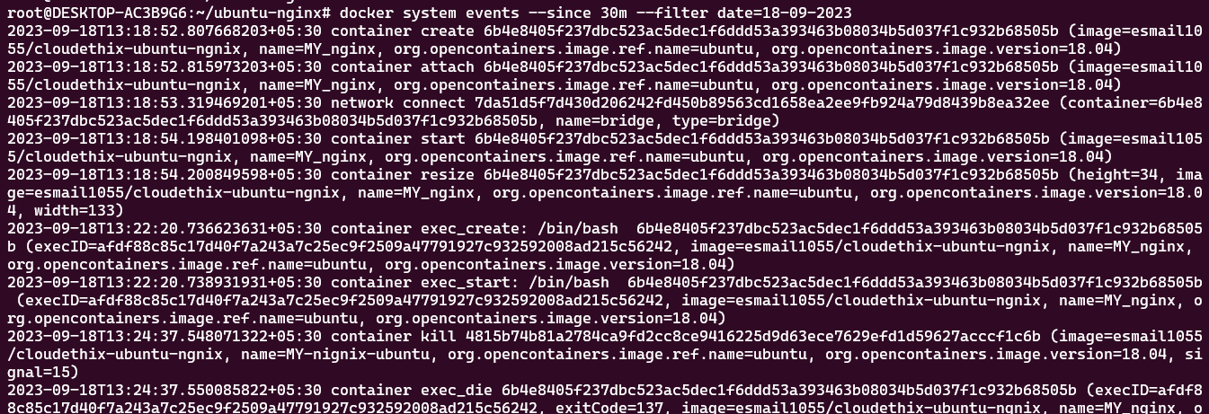

Thank You